# 26. Oct 20

## 7:14pm

* Tried to implement the strategy with Bollinger bands + RSI
* Checking whether both breaches have been made (i.e. above 75 threshold on RSI as well as close above the Bollinger band and vice versa on bottom side for 25 threshold on RSI) AND that the last bar had an action which went in the desired direction

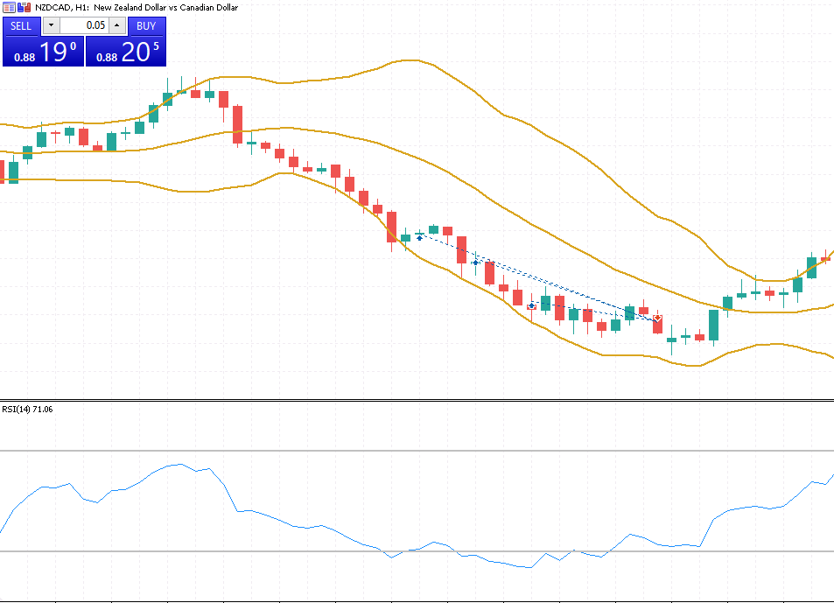

* From the arrows above, left to right:
  + 2 bars ago from the current bar, the RSI and Bollinger band condition is met
  + Previous bar (1 bar ago) the bar goes in the desired direction of action
  + Current bar would be a *buy* trade in this case
  + This case above would only yield 5 pips
* Code for this check:

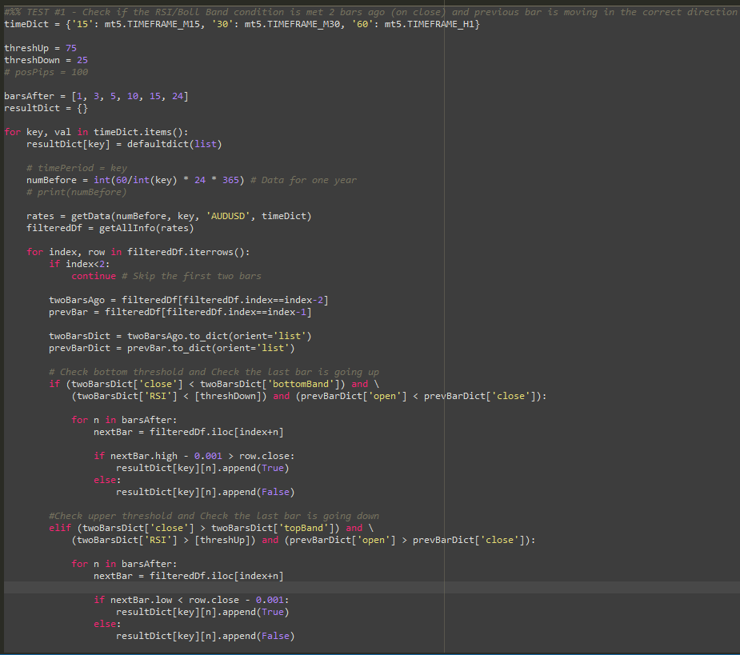

* Result dictionary contains dictionaries for each of the timeframes tested and a list of truth values for the number of bars afterwards tested for a winning trade
* Example below:

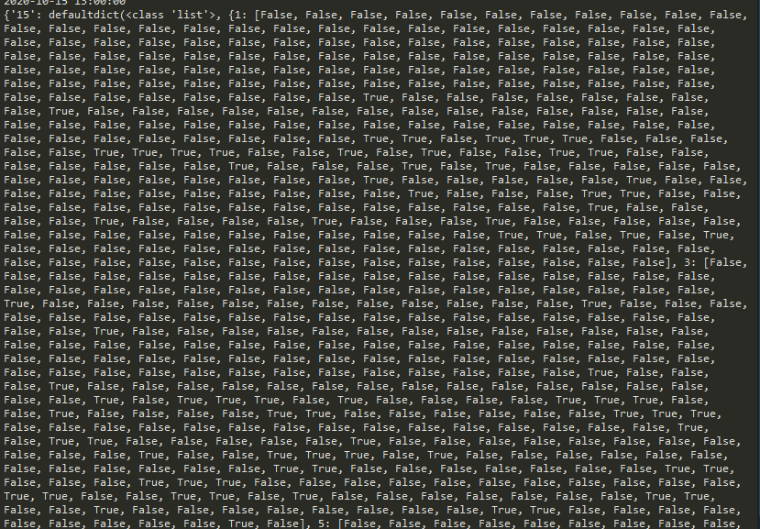

* Example for the H1 time frame and a correct matching of the conditions above:

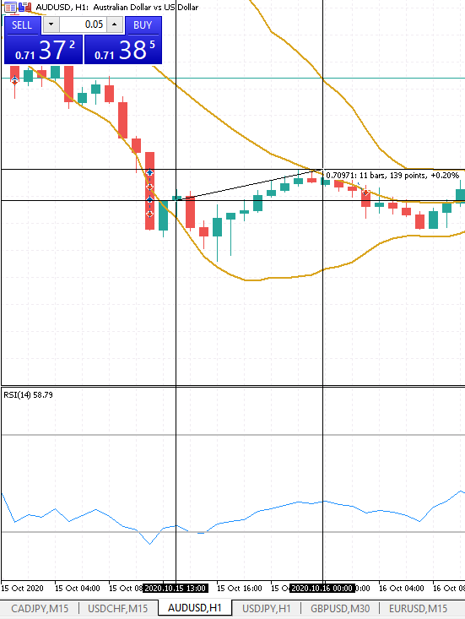

* The above trade yielded 13.9 pips in 11 bars (or in this case, 11 hours), however the result showed that for *barsAfter* values of 1, 3, 5, 10, 15 and 24, the result was false
* Change the code so that it is inclusive of all of the bars not just looking at that n-th bar

## 7:31pm

* Results from the updated test:

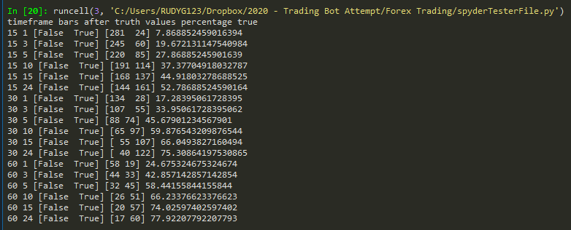

* 24 bars afterwards on the M30 time scale and on the 60 minute time scale (H1) result in roughly 75% chance of getting 10 pips (i.e. for a lot of 0.1 = $10)

# 27. Oct 20

## 9:50am

* Doing a similar check for just a simple Bollinger band bounce back –
* Time frame in minutes shown on left, then the number of bars afterwards (only held to maximum of 10 bars, as scalping is desired)
* Truth values and percentage of times true (for 5 pips in the right direction)

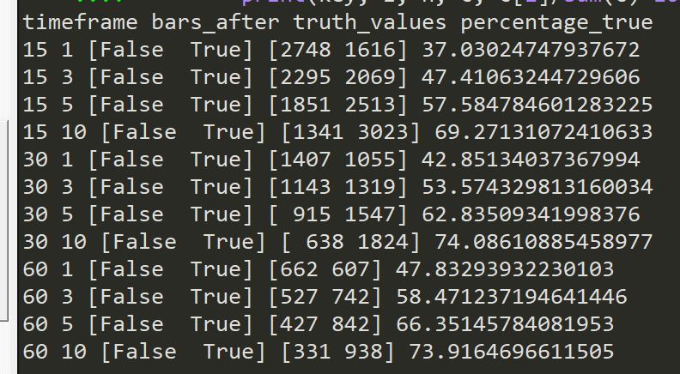

* Results for 10 pips:

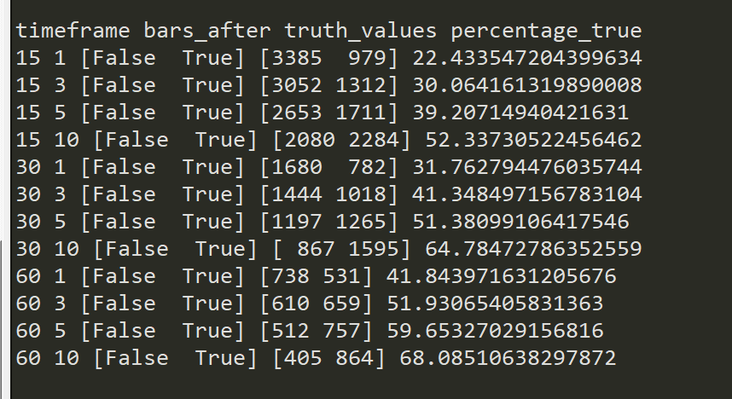

* **Looking for a success rate of > 80% in the following 10 bars or less**

## 10:12am

* Modifying the algorithm for a slight error:

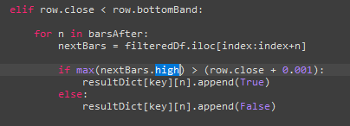

* The above code previously checked if the low value of the consequent bars consisted of a positive direction change when a breach of lower boll band occurred
* Now changing it to the high value:

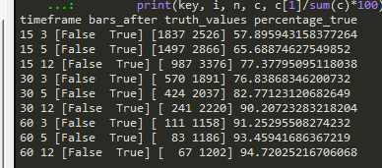

* Could write an algorithm with check for 5 hours after implementation on the 1-hour timeframe (93% accuracy) and Stop Loss implemented if this did not occur

## 10:29am

* Above was for GBPUSD
* Below for AUDUSD:

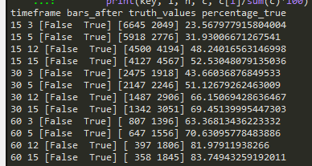

* For USDCHF:

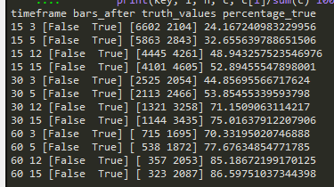

* Above is for an increase of 0.001 but could depending on the currency pair
* Update: all above currency pairs are moving with 5 decimal points so 0.0001 is one pip – therefore 0.0010 is 10 pips

## 9:33pm

* Test #3 - use the Bollinger bands and a close in the positive direction:
* For AUDUSD

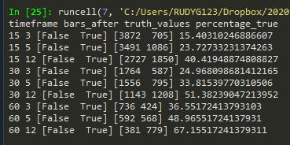

## 9:40pm

* Changing the bollinger band test so that it doesn’t include the current bar when checking the consequent bars



* Previously was index:index+n (which includes the current bar)
* Results for AUDUSD:

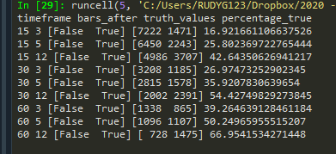

* Much worse results given that the low value of the current bar is not taken into account – probably skews data
* Results for GBPUSD:

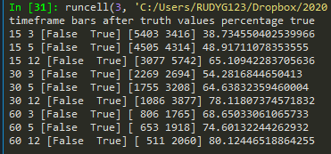

# 28. Oct 20

## 3:17pm

* Trying to check the RSI + Bollinger band method (with one close in the correct direction) for the bars *after* the current bar for 3-4 different pairs
* First check AUDUSD (1 year of data):

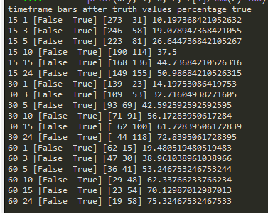

* AUDUSD for 2 years of data:

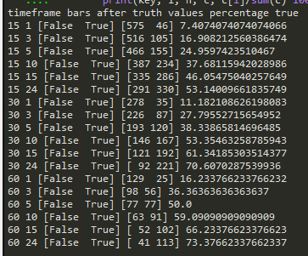

* AUDUSD for 0.5 years:

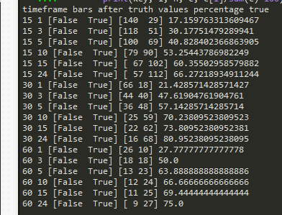

* USDCHF for 1 year:

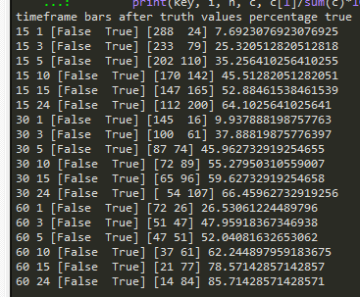

## 4:07pm

* Doing a test simply for the breach of RSI on the 75 or 25 limits for AUDUSD on 2 years of data:

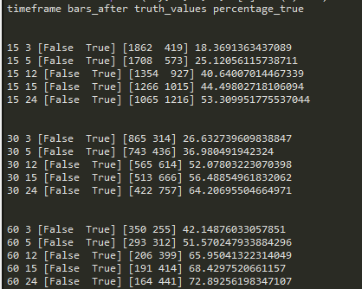

* For USDCHF for 2 years:

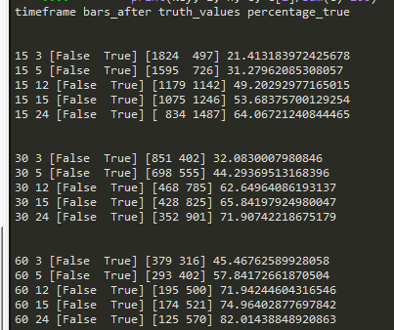

* For GBPUSD for 2 years of data:

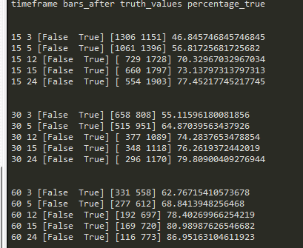

## 6:27pm

* Idea to test the theory on just GBP pairs as they have higher chance of winning compared to the other pairs analysed
* Doing the RSI breach of 75 and 25 points
* Use 2 years of data, GBPUSD, GPBCHF, GBPAUD, GPBCAD and GBPAUD:

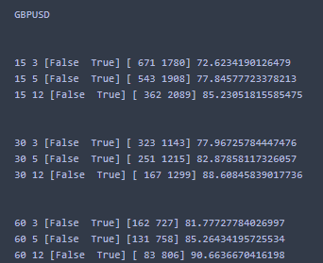

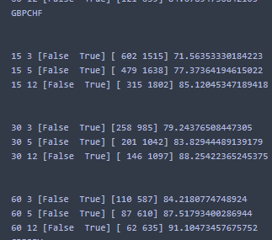

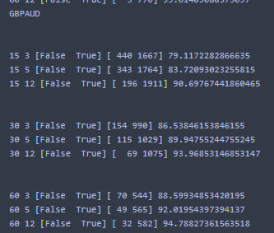

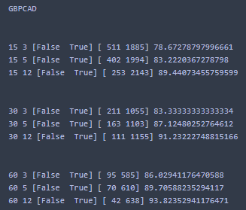

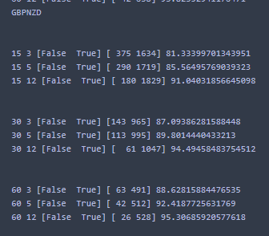

* For these pairs, very good chance overall that the trade will win (5 pips or more)

# 30. Oct 20

## 7:19pm

* Using the Bollinger band and the

# 4 Nov. 20

Notes from Evernote:

**14-OCT-20**

Ideas to try:

* Just using the RSI going below/above the thresholds and not the combo with boll band
* Using the idea of the gradient of the last 5 bars or so of the RSI to see a sharp up or down

**15-OCT-20**

* Go through the last 2 years worth of rates and implement the strategy by just checking threshold. Note the low and the high price average 5 bars after each hit of the threshold

**16-OCT-20**

* Use the low and the high to check the strategy working rather than the close

**Simple + profitable scalping strategy (YouTube video) - 23OCT20**

Link - <https://www.youtube.com/watch?v=zhEukjCzXwM&t=206s&ab_channel=ForexSignalsTV>

* Use two charts (M5 and H1) and the H1 serves as the confirmation/anchor chart
* H1 chart helps to identify whether to buy or sell

On H1 chart:

* Use the 8EMA and 21EMA (exponential moving average) on the H1
* If 8 < 21 then sell, 8 > 21 then buy the market
* Also confirm the price of the bars is on the correct side (i.e. if you want to sell then the price should be below the EMAs)

On M5 chart:

* 8, 13 and 21 EMA
* Wait for the fanning out of the different lines (i.e. spreading out)
* Wait for the pull back (i.e. when a bar hits the 8EMA) and this becomes our trigger bar and notes when to trade
* Count back 5 candles and identify the lowest point
* Entry point becomes -3 pips below this lowest point (on a sell trade and vice versa on a buy trade)
* Stop loss becomes +3 pips above the trigger bar
* TP is equal to the SL but in the other direction (1:1 risk)

To catch the longer trend, keep moving the SL to the low/high of the 3 bars behind the current bar (for buy/sell, respectively)

## 8:29pm

* Use the Scholastic oscillator and the red line in the metatrader window – identify what this line refers to
* Use these settings:

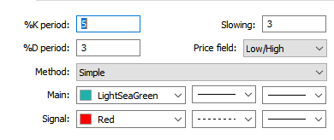

* Thresholds of 85 and 15 to just take 10 pips at a time, try to get TP and SL of 10 pips at a time, running on GBP pairs initially but test with other pairs
* Another idea is to check when the main+signal intersect and if the following bars go down by 10 pips

# 8 Nov. 20

## 2:43pm

* Try the above method by looking at and calculating the scholastic oscillator with the settings given above

# 14 Nov. 20

## 4:25pm

* Watching the video by *The Swag Academy* on YouTube “How to Trade With Fibonacci Retracement | Step-By-Step Guide”
* With the Fib retracement use these settings:
* Learn what the Japanese candlesticks mean:
  1. Doji
  2. Hammer
  3. Shooting star/evening star/morning star
* Use the following indicators:
  1. Trend line
  2. Support/resistance
  3. Fib
  4. Moving average
  5. Japanese candlestick patterns